***EXPERIMENT NO.9 MULTITHREADING***

Program :-

public class multi1 extends Thread

{

public void run()

{

System.out.println("Thread is Running.....");

}

public static void main(String arhs[])

{

multi1 t1=new multi1();

t1.start();

}

}

OUTPUT:-

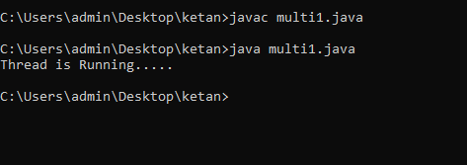

2} Program:-

public class multi2 implements Runnable

{

public void run()

{

System.out.println("Thread is Running.....");

}

public static void main(String args [])

{

multi2 r1=new multi2();

Thread t1=new Thread(r1);

t1.start();

}

}

OUTPUT:-

